PRESS RELEASE

No.52/SP/TKP-ASEAN2023/04/2023

PUBLIC COMMUNICATION TEAM

Dekranasda Prepares Locally Made Shirts for ASEAN Heads of State

Jakarta, Kominfo Newsroom – The East Nusa Tenggara Handicraft Council (NTT Provincial Dekranasda) prepared shirts made from West Manggarai woven fabrics for eleven ASEAN heads of state and the ASEAN Secretary General at the 42nd ASEAN Summit in Labuan Bajo, West Manggarai, East Nusa Tenggara.

"I have prepared them, sent them to the State Palace. [They are] from MSMEs in Lembor Subdistrict, and the President himself decided which head of state to use which color; he made the decision," said the Head of NTT Provincial Dekranasda, Julie Sutrisno Laiskodat, in Labuan Bajo, Manggarai West, Thursday (27/4/2023).

The West Manggarai weaving, especially from Lembor District, uses the mata manuk (chicken eye) pattern.

For the color and model of the woven fabric, said Julie, President Joko Widodo had personally made his choice.

Furthermore, the NTT Provincial Dekranasda prepared scarves to be used by the spouses of the heads of state or the first ladies in the Spouse Program. First Lady Iriana Joko Widodo chose the color and model of the shawl to be used.

In accordance with President Joko Widodo and First Lady Iriana Joko Widodo's directives, she continued, the attire that will be used later is made of soft and cool material.

Julie expressed her pride that the typical woven products of NTT, especially West Manggarai, were prepared for the heads of state and spouses to wear on one of the activity days.

She expected the use of woven products to become an arena for promoting woven intellectual property with the historical and cultural value that deserves appreciation from all parties.

Therefore, the people of West Manggarai can be proud when heads of state wear woven shirts with the mata manuk pattern.

"We must be proud that our products will be used by ASEAN heads of state later," she said proudly. (Francisca/TR/Elvira)

***

For further information, please contact:
Director General of Public Information and Communications of the Ministry of Communications and Informatics – Usman Kansong (0816785320).

Get more information at https://infopublik.id

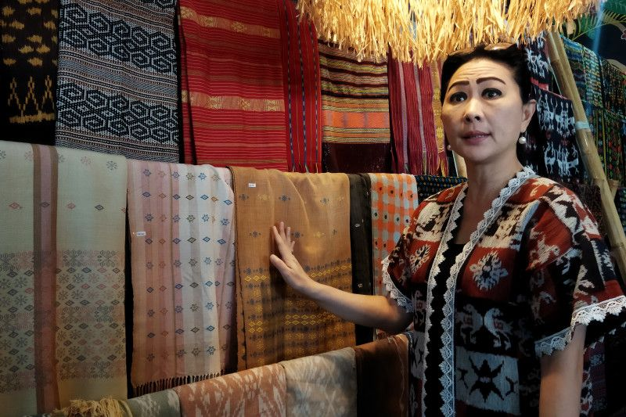

Head of NTT Provincial Dekranasda, Julie Sutrisno Laiskodat, shows examples of woven fabric models that will be used by ASEAN heads of state later, Labuan Bajo, West Manggarai, NTT, Thursday (27/4/2023). (ANTARA/Fransiska Mariana Nuka)

